Using Geogebra to explore the sum of interior and exterior angles of polygons

This is an assessed assignment based on Criteria B (Investigating Patterns) and Criteria C (Communication in Mathematics).

For this assignment, you will be using an interactive geometry application called Geogebra. Prior to opening Geogebra, answer the following questions using only your background knowledge of Geometry.

Part I
- What do you think is the sum of the interior angles of a triangle? A rectangle? A pentagon?
- Would your answers be true for any triangle, rectangle or pentagon?
- What is the sum of the exterior angles of a triangle? A rectangle? A pentagon?
- Would your answers true for any triangle, rectangle or pentagon?

We will now verify your ideas using interactive geometry software: Geogebra.
- Open Geogebra.
- Go to VIEW to deselect the axes and then select the spreadsheet view.
- Adjust the windows to give yourself space.
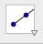
- Select the RAY tool (part of the 3rd tool to the left choices). You will have to choose it from the pull down menu that appears when you click on the red down arrow in the bottom right corner of the tool.
- Create your polygon. By the way, you can double click on any object and select OBJECT PROPERTIES. There, you will find that you can choose to show/change/hide the label, change the colour, thickness, etc… Explore!
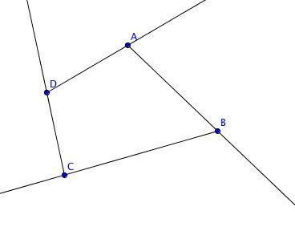
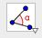
- Select the ANGLE tool (8th from the left) and select your angles. To do this, pick the lines that encompass your exterior angle making sure you go counter clockwise (like we always measure angles in math). For the interior angles, pick the three points as you would normally to name the angle (don’t forget… counter clockwise).
- Select the TEXT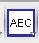 tool (10th from the right), select a place to put it on your workspace and type in the following: 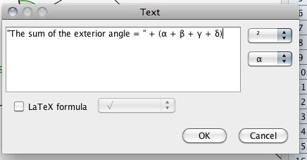
- What is in quotations remains as text, without quotations, it is a formula and you can string them together with the plus sign. Special symbols can be found in the pull down menus on the right.
- Repeat this to create a text box for the interior angles.
- Move your points and you can verify if the sum is always the same.
- You can repeat this process for different numbers of sides of polygons. You can delete the last side you did (and a few of the angles that went with it) and build from there. You can delete an object by selecting it and pressing delete.
- Add your data to your spreadsheet list. Example: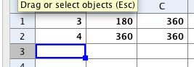
- Examine any patterns here.
- Getting fancy: Delete your sketch (select all items and hit delete). You can now graph the results. Go to VIEW to bring back the axis. Select the two columns you want to plot. Right click and select CREATE A LIST. Change you scale in OPTIONS -> GRAPHICS VIEW to set your x and y axis to an appropriate scale. Select the BEST FIT LINE tool (4th from the right) and select all the points. Use the text box to add a title etc… You can double click on the line, select OBJECT PROPERTIES and select SHOW LABEL: NAME AND VALUE. This way you see the equation on the graph.

Provide an explanation for the following:

- Were your predictions at the beginning correct? Describe.

- Describe the patterns that you discovered throughout Part I of the activity (including any patterns discovered in your table).

- Write the patterns found in your table as an equation. Let’s say that the number of sides is n and the sum of the exterior angle is S_{e} and the sum of the interior angle is S_{i}.

- Patterns and mathematical formulas to describe patterns permeate mathematics. Describe this statement.

- Use your equation to determine what the sum of the interior angles would be for a polygon with 100 sides?

- Could the procedure in Part I be done with 3-D objects? Explain why or why not.

Part II
- Now, open up the second Geogebra file that has been sent to you, it is called Parallel Lines. Explore the patterns found in the various angles created by the parallel lines. Be sure to move the parallel lines around to see how the angle measurements change.

- Click on each of the tick boxes and describe the patterns demonstrated by each type of angle shown.

- Identify all of the angle pairs for each of the four angle types.

